# **Operating Systems**

# **- How to access Linux via Putty**

**Aim: To start using Linux.**

1. To start using Linux you can:
   1. connect to a Linux Server across the network; using **Putty**
   2. Boot up Linux in a “stand-alone” computer (e.g. **Virtual box**) .
2. In these Labs we will be using the School of Computing networked Linux teaching server – **147.252.234.34** , your ict domain credentials will give you access.
3. To access a Command Line Interface (CLI) the application PuTTY located on the lab PC desktop is utilised. When we speak of the command line, we are really referring to the shell. The shell is a program that takes keyboard commands and passes them to the operating system to carry out. Almost all Linux distributions supply a shell program from the GNU Project called bash. The name “**bash**” is an acronym for “**B**ourne **A**gain **SH**ell”, a reference to the fact bash is an enhanced replacement for sh, the original Unix shell program written by Steve Bourne.

PuTTY is a “terminal emulator” program which allows Windows users to connect to remote systems over a network using Telnet and SSH protocols . While both Telnet and SSH allow you to connect to remote systems, SSH, supported in PuTTY, provides for a "Secure Shell", encrypting information before it is transferred. This way, it is harder for others to intercept passwords and other private information.

1. Start the application, use the ip address: 147.252.234.34

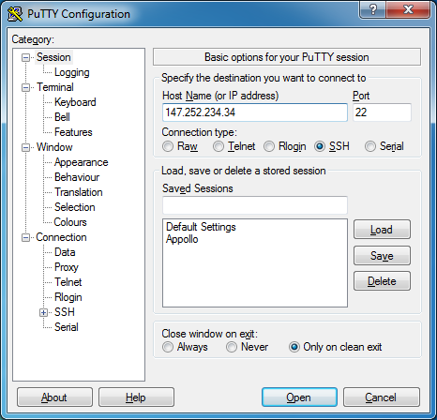

1. Then on the terminal screen that appears, provide your **ict** **username (ICTDOMAIN\denis.manley)** and **password** to access the server, then you should see something like this. This is called a shell prompt and it will appear whenever the shell is ready to accept input.

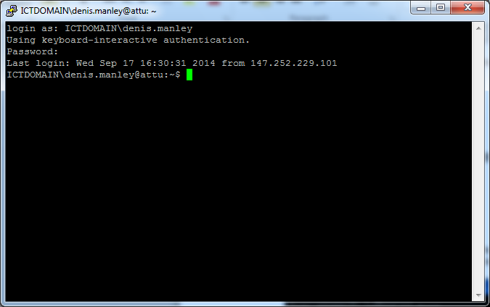

While it may vary in appearance somewhat depending on the distribution, it will usually include your ICTDOMAIN\username, followed by the current working director and a dollar sign. If the last character of the prompt is a hash sign (“#”) rather than a dollar sign, the terminal session has superuser or root privileges.

1. To test the connection: Type date at the prompt like:

ICTDOMAIN\username**:~$ date**

It should give you the following:

